DISTAL RADIUS ORIF POST OP INSTRUCTIONS- DR. PETER DENOBLE

WHAT DO I DO AFTER SURGERY?

Immediately after your surgery you will be wearing a splint that incorporates the wrist. You will be able to move your fingers and finger range of motion is actually encouraged post operatively. You will need to remain in your splint and be sure to keep it clean and dry over the next 2 weeks.

When do I schedule my follow up appointment?
Call our office at 973-898-5999 to schedule your first follow up visit 2 weeks after your procedure. At your first follow up appointment your splint and dressing will be removed. X-rays will be taken and reviewed. At this point you will be placed into a removable brace which can be removed for range of motion.

Call our office at 973-898-5999 to schedule your first follow up visit 2 weeks after your procedure.

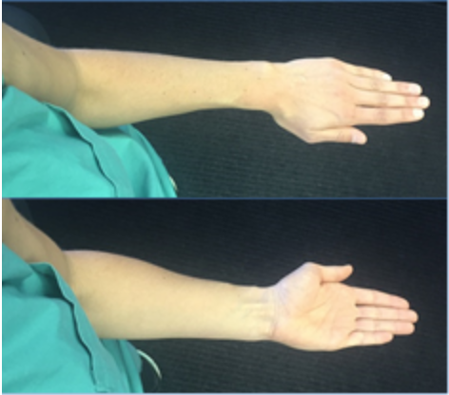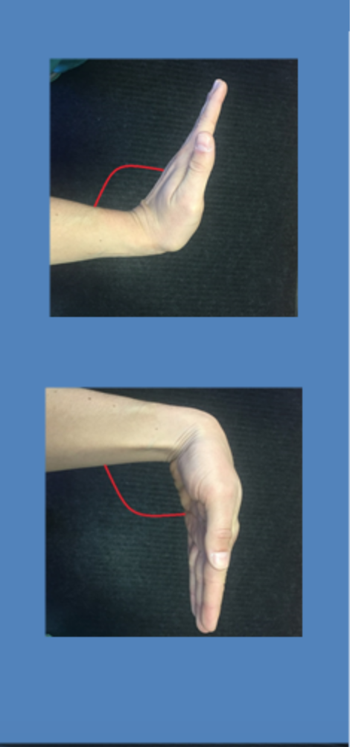

Physical therapy is prescribed if you are in need of or desire guided rehabilitation. Some patients choose to do therapy on their own. There are four main motions (pictured above) to focus on when looking to regain wrist range of motion. Time should be spent several times a day focusing on stretching the wrist in each of these four motions. Place and hold exercises are important- this requires you to stretch your wrist to a point when you feel the stretch and then hold it in that position. This will help stretch and loosen the tissues surrounding the wrist joint, allowing you to slowly increase your range of motion day by day. Ideally, you can compare the wrist motion to that of the unaffected wrist.

Helpful tips:
- Ice and elevation (keeping your hand above the level of your heart) are both very helpful during the early post op period.
- If you notice that your hand appears to be swelling it is most likely because it needs to be elevated or your dressing may be too tight (if you get permission from your doctor you may be able to loosen the outer dressing).
- Some patients find it alarming to see bruising in their fingers and hand after surgery, but this is quite normal.

